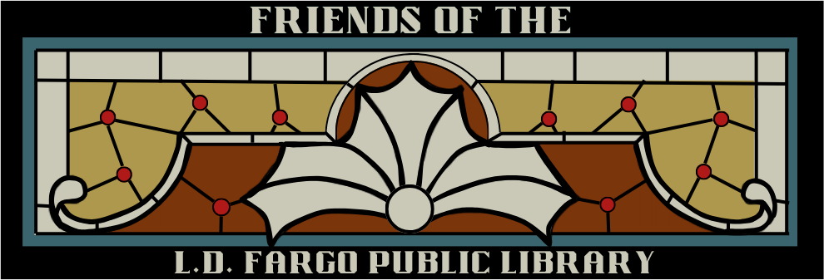

The Friends of the
L.D. Fargo Public Library

Page Scholarship Program


The Friends of the L.D. Fargo Public Library

120 East Madison Street Lake Mills, WI 53551 920-648-2166
fol.ldfargo@gmail.com

The Friends of the L.D. Fargo Public Library Page Scholarship Program

The Friends of the L.D. Fargo Public Library was founded in 1987 to support the library staff and the
L.D. Fargo Public Library Board; sponsor programs designed to improve the social, cultural, and intellectual life of the community; and promote the library in all phases of community life.

The Friends of the L.D. Fargo Public Library announces The Friends of the L.D. Fargo Public Library Page Scholarship Program. Under the Program, one (1) $1000 scholarship will be awarded to a high school senior.

Eligibility:

- Minimum one year employment as a page at the L.D. Fargo Public Library; from date of hire till last day of employment
- Scholarship will be awarded to a student completing his/her senior year at the Lake Mills Public High School, Lakeside Lutheran High School, or in a Home School Program.

Criteria:

- Page Scholarship Application
- Grade point average 3.0
- Transcript of grades
- Completion of one volunteer activity for the Library and/or Friends of the Library event
- Short essay stating; how working at the library left a positive influence in your life
- Letter of Recommendation – from the L.D. Fargo Public Library Director
- Scholarship to be used towards an accredited 2–4-year college or technical school for study in any field
- All information must be received by March 20th of senior year. Late applications will not be accepted.

Guidelines:

- Only qualified applicants will be considered.
- One scholarship per year will be awarded.
- Scholarship will not be awarded if there is no qualified applicant.

Summary of Scholarship Requirements:

- A completed scholarship application
- Official grade transcript
- Essay
- Letter of Recommendation from the L.D. Fargo Public Library Director

The Friends of the L.D. Fargo Public Library Scholarship Committee will review the applications and select the recipient. The scholarship will be awarded at the Lake Mills High School awards program unless the recipient is a student at Lakeside High School or is home schooled. A formal invitation will be sent to student.

Applications may be downloaded from The Friends of the L.D. Fargo Public Library website at: lakemills.lib.wi.us
Please submit any questions to: beckiekane8@hotmail.com

The Friends of the L.D. Fargo Public Library

120 East Madison Street Lake Mills, WI 53551 920-648-2166
lakemills.lib.wi.us

FRIENDS OF THE L.D. FARGO LIBRARY PAGE SCHOLARSHIP APPLICATON

Please print legibly: Date:

Last Name:
First Name:
MI:

Address:
City:
State: Zip Code:

Cell Phone: E-mail:

High School:

High School Address:

Information

Date of hire: Last date of employment:

Grade Point Average: (Attach official Grade Transcript)

Volunteer Activity (Library and/or Friends of the Library event)

Activity: Date:

College/Technical School attending: Enrollment Date:

Essay

Short essay stating; how working at the library left a positive influence in your life

Letter of Recommendation

Attach a letter of recommendation from Director of Library stating why you are deserving of this scholarship.

Attachments Reminder: The following attachments must accompany your scholarship application:
- Official Grade Transcript
- Essay
- Letter of Recommendation

================================================================================
I hereby understand I will not submit this application without all required attachments and supporting information. Incomplete applications or applications that do not meet eligibility criteria will not be considered for this scholarship.

Signature of Scholarship Applicant Date
================================================================================

For Friends of the L.D. Fargo Public Library Scholarship Committee Use Only

Received by FOL Scholarship Committee:

Committee Member Date

Reviewed by FOL Scholarship Committee:

Committee Member Date

Committee Member Date

